Salesforce Products:

The Salesforce CRM categories of products are created in a way that they are deeply integrated and often share the same tools or modules. The major Salesforce products to be explored include:

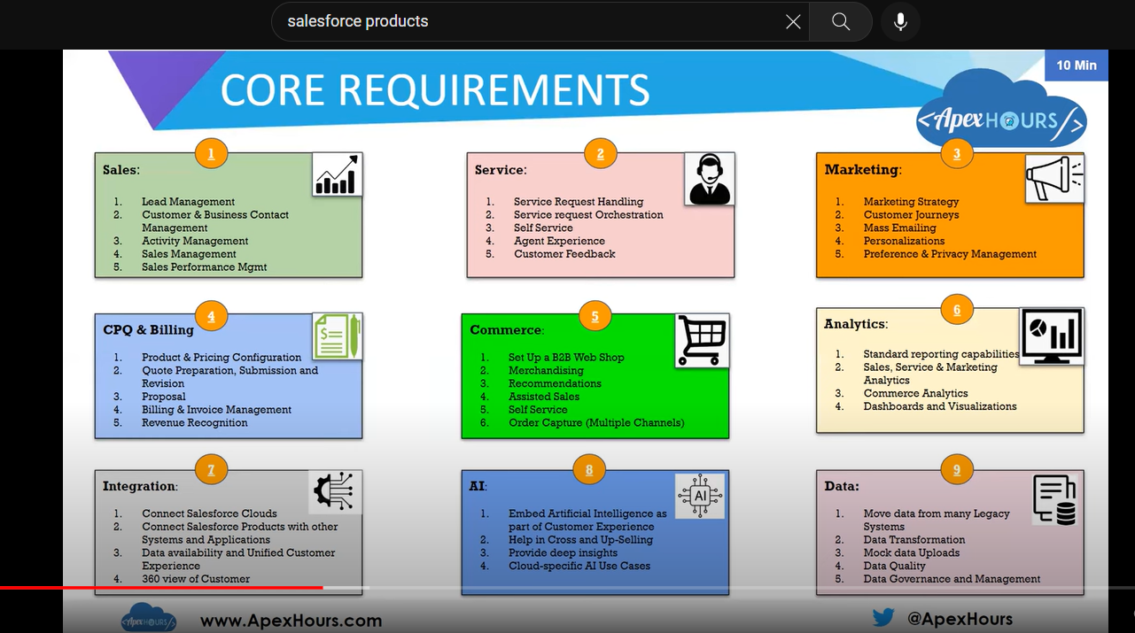

**Salesforce Sales Cloud:**

[Salesforce Sales Cloud](https://cyntexa.com/salesforce-sales-cloud-implementation/) is a CRM tool that can be used to drive the company’s growth by managing accounts, find customers and close deals. Some of the top features of the Sales Cloud include contact management, opportunity management, lead management, reports and dashboards, sales forecasting, workflows.

### Salesforce Service Cloud

[It specializes in providing state-of-the-art customer service.](https://trailhead.salesforce.com/en/content/learn/modules/service-cloud-platform-quick-look) Through the [Salesforce Service Cloud](https://cyntexa.com/salesforce-service-cloud-implementation/), the users can deliver more personalized support through various channels that include email, live chat, and phone. It includes a self-service portal with a custom-branded community that enables customers to look for answers independently.  
**Salesforce Live Agent**is a solution that includes additional digital service channels. Its features include a personalized live chat which helps the users engage customers in real-time both online and in-app. Here, each live chat is connected to the customers’ profile which delivers support in-context while contributing to overall customer experience.

**Salesforce Field Service Management:**The cloud marketing automation platform of CRM empowers the user to deliver relevant and personalized journeys across different channels and devices. The cloud marketing platform developed for marketers allows them to send the right messages to the right recipient at the right time throughout all phases of the customer relationship. It covers each customer interaction and engagement so that the marketers can guide customers’ on a one-to-one journey with ease and efficiency.

**Salesforce Live Message**is a mobile messaging solution that helps users stay connected with their customers at any point in time. It offers a convenient method of providing a solution without the user being bound to the web browser. The users can also have personalized conversations with customers via SMS or Facebook Messenger.

### Salesforce Marketing Cloud

**Salesforce Marketing Cloud**is a cloud marketing platform that empowers users to deliver relevant and personalized journeys across different platforms and devices. It was developed for marketers so that they can conveniently send the right messages to the right recipients throughout the various phases of the customer relationship.

**Marketing cloud products**

1. **Salesforce journey builder**– used to deliver personalized and connected cross channel experiences for customer interaction at every phase. It also helps the user align to the customer needs quickly and efficiently.
2. **Salesforce email Studio**– helps create basic and sophisticated marketing campaigns. It unifies data from each department to build a smart and effective email campaign.
3. **Salesforce Advertising Studio**– integrates and CRM data with digital advertising. Connecting the channels gives users consistency and helps the users gain new prospects based on the behaviour of the user’s current high-value customers.
4. **Salesforce Mobile Studio**– enables the users to reach the customers through SMS marketing, group messages and push notifications. It also targets a new audience with the help of customer preferences and behaviours and sends relevant messages to drive engagement.
5. **Interaction Studio**– allows users to visualize, monitor and manage customer experiences in real-time. It includes native integration with the Salesforce platform’s marketing, sales and service solutions, which helps it to easily trigger events and communication in real-time.
6. **Social Studio**– combines marketing solutions with sales and service with popular social media platforms. It focuses on creating, approving, and publishing content on social media platforms and accounts with brand consistency.

**Salesforce Commerce Cloud**[helps the brand grow faster and convert leads to customers**.**](https://trailhead.salesforce.com/en/content/learn/modules/cc_ccbasics) It gives the users a complete view of the inventories, orders, and activities. It is available in B2B and B2C commerce stand-alone product lines or as an end-to-end unified commerce product.

**Commerce Cloud Solutions** is designed to transform shopping experiences with the help of AI in all digital channels. Its products include:

* Salesforce Order Management- transforms stores into distribution centres by activating and selling in-store products online.

**Salesforce Community Cloud**helps the user build a platform for everyone important for the business ecosystem. The users collaborate and connect customers, employees, and partners, and also get in touch with job applicants, agencies, vendors, suppliers, and retail locations, among others.

 The advantages of Community cloud are,

* Create multiple communities based on business needs.
* Employees, Partners, and Customers get access to business processes.
* Integrating data from third-party providers.

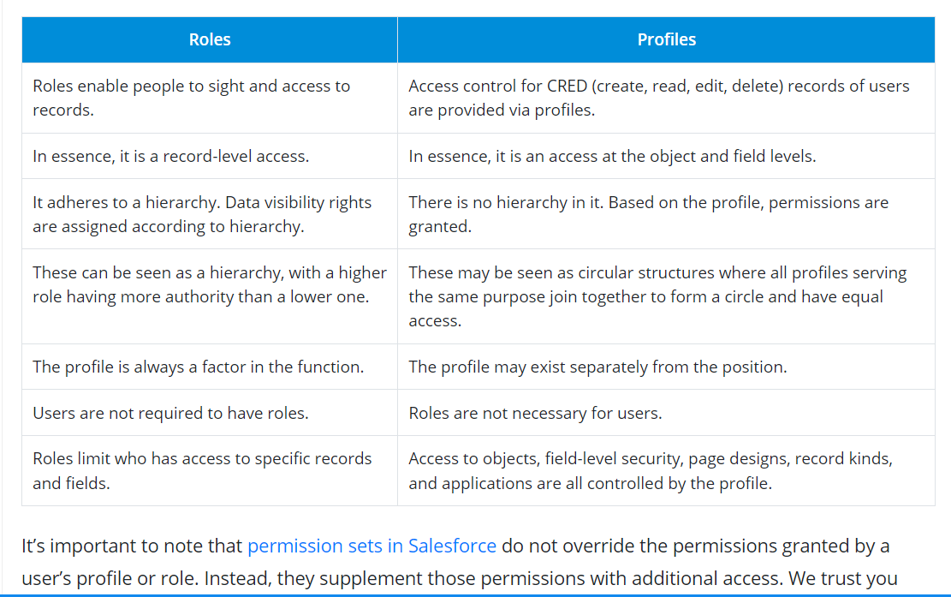

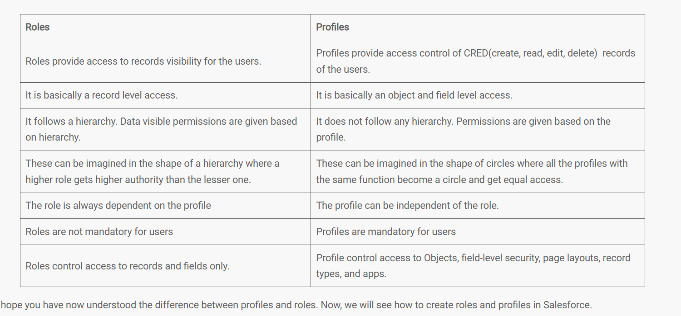

**1.salesforce products:**

**2.tabs defect on page 6**

Commerce Cloud is a key part of the Salesforce Customer Success Platform and offers ecommerce solutions for B2C (business to consumer) and B2B (business to business) customers. That means that organizations purchase Commerce Cloud to provide the best ecommerce websites to their customers who are shopping online

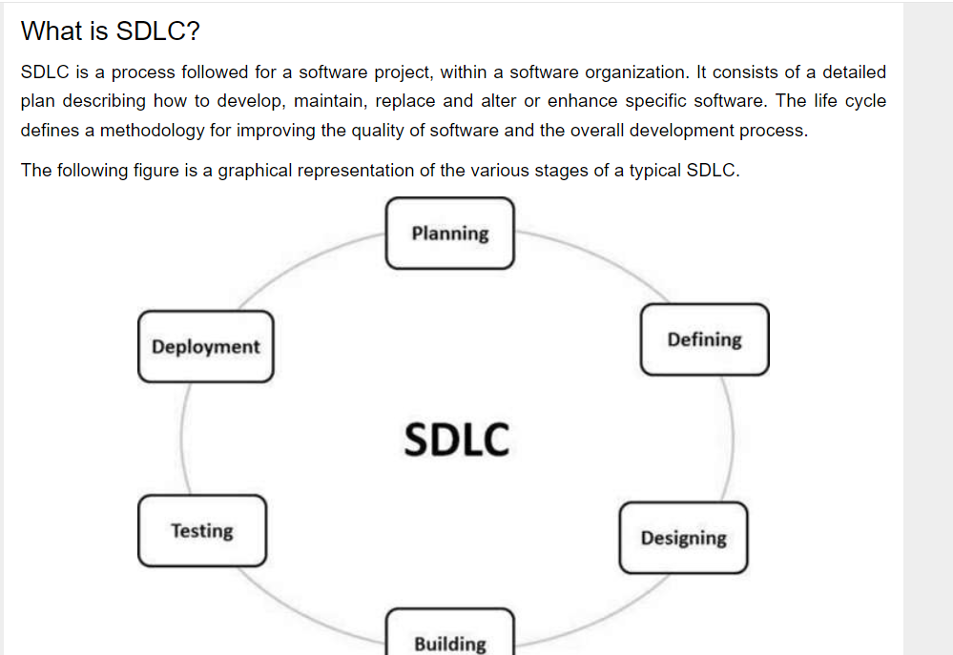

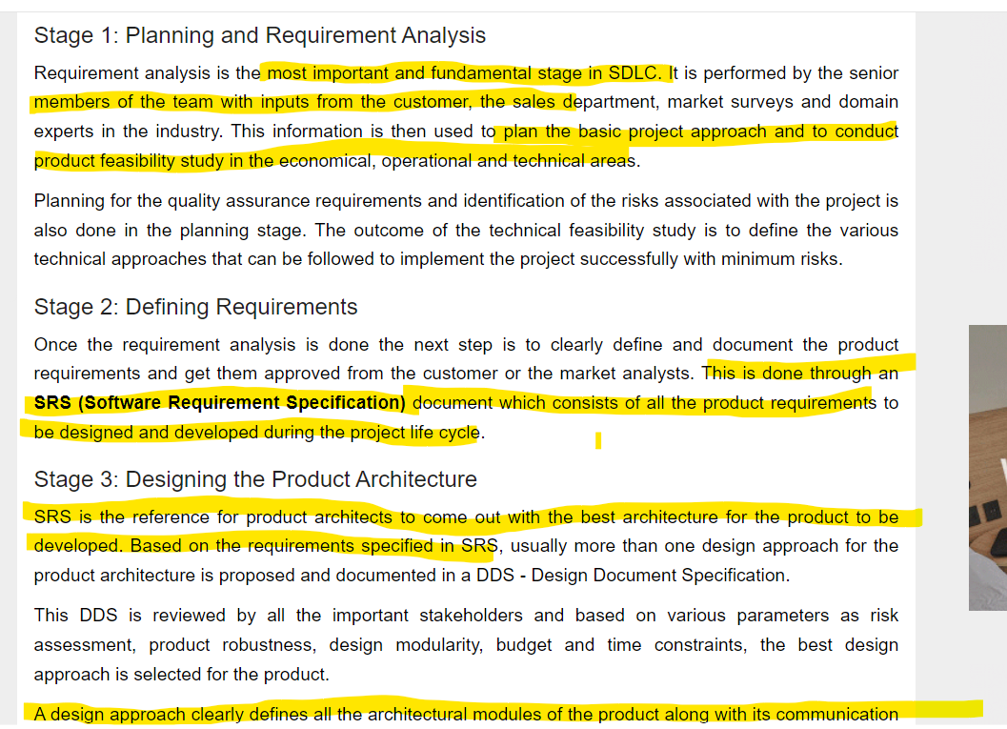

c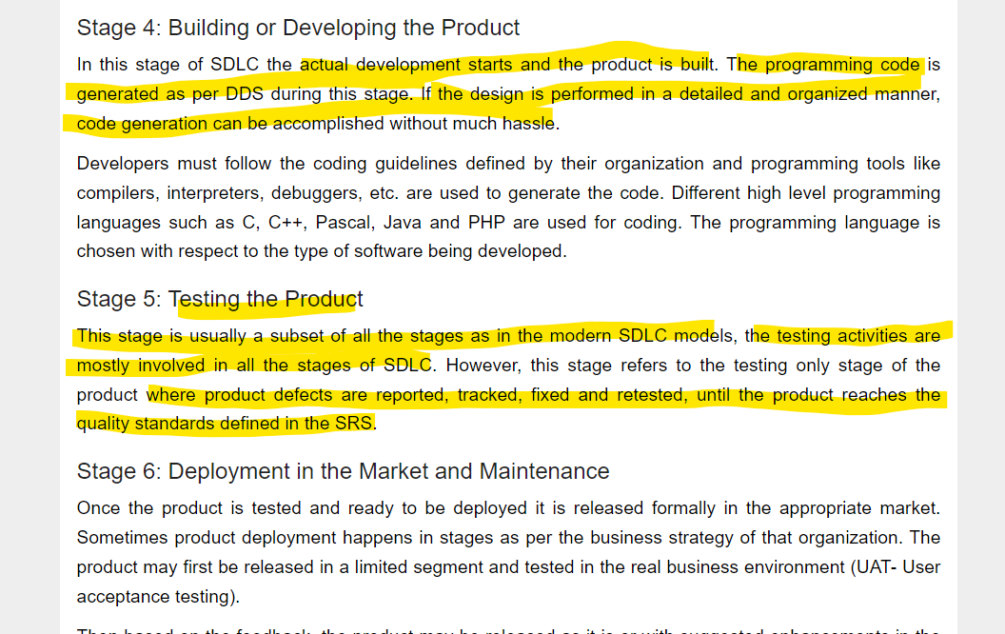

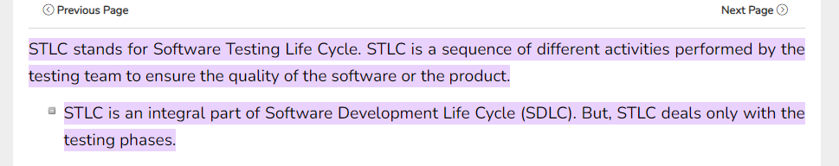

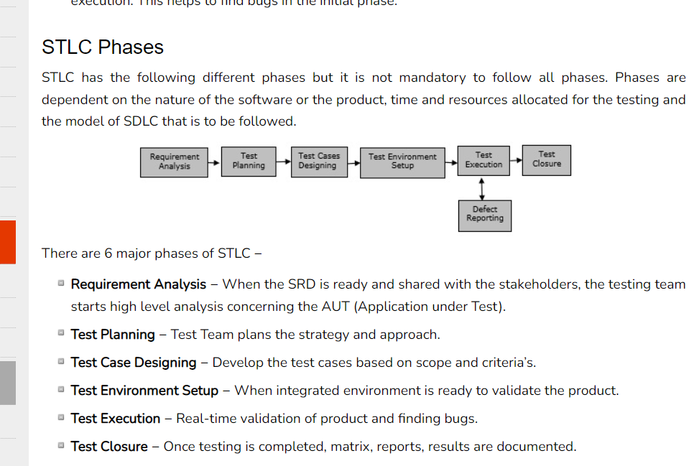

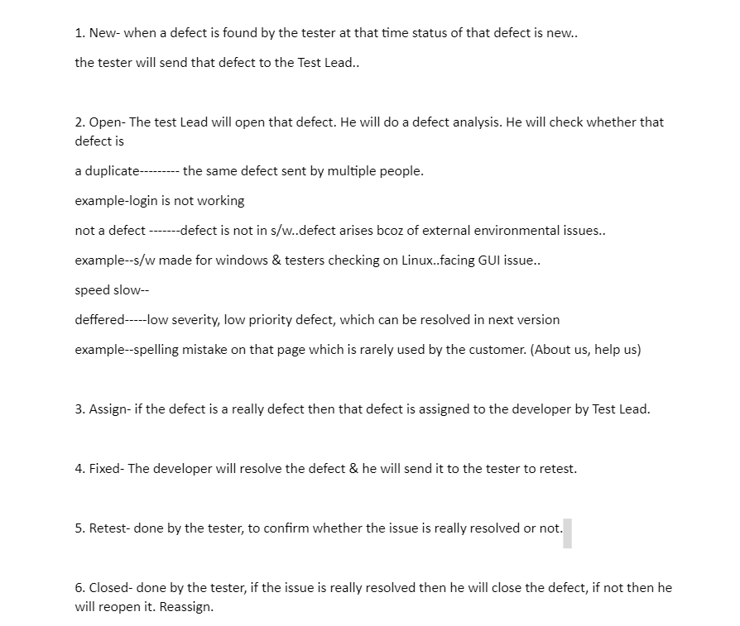

The different types of reports in [Salesforce](https://www.simplilearn.com/how-salesforce-certification-accelerate-career-article) are:

* Tabular report that displays the grand total in table form
* Matrix report where grouping is based upon both rows and columns
* Summary reports are detailed reports in which the grouping is based on columns.
* Joined report which allows two or more reports to be joined in a single report

-----The Audit Trail function in Salesforce is useful for gaining information or for tracking all the recent setup changes that the administration has done in the organization. The audit trail can preserve data for up to six months.

Governor limits control how much data can be stored on a shared database. They help to ensure that no one monopolizes the shared resources (Storage, CPU, Memory).

Here are some few examples of governor limits in Salesforce:

* Maximum CPU time on the Salesforce servers - 10,000ms
* Total number of send Email methods allowed - 10
* Total number of records retrieved by a SOQL query - 50,000
* Total number of callouts in a transaction - 100

### What is the difference between Trigger and Workflow?

This is one of the most frequently asked Salesforce interview question. Workflow is an automated process that fires an action based on evaluation criteria and rule criteria. As described above, Trigger is the code that is executed on or after the record is updated or inserted.

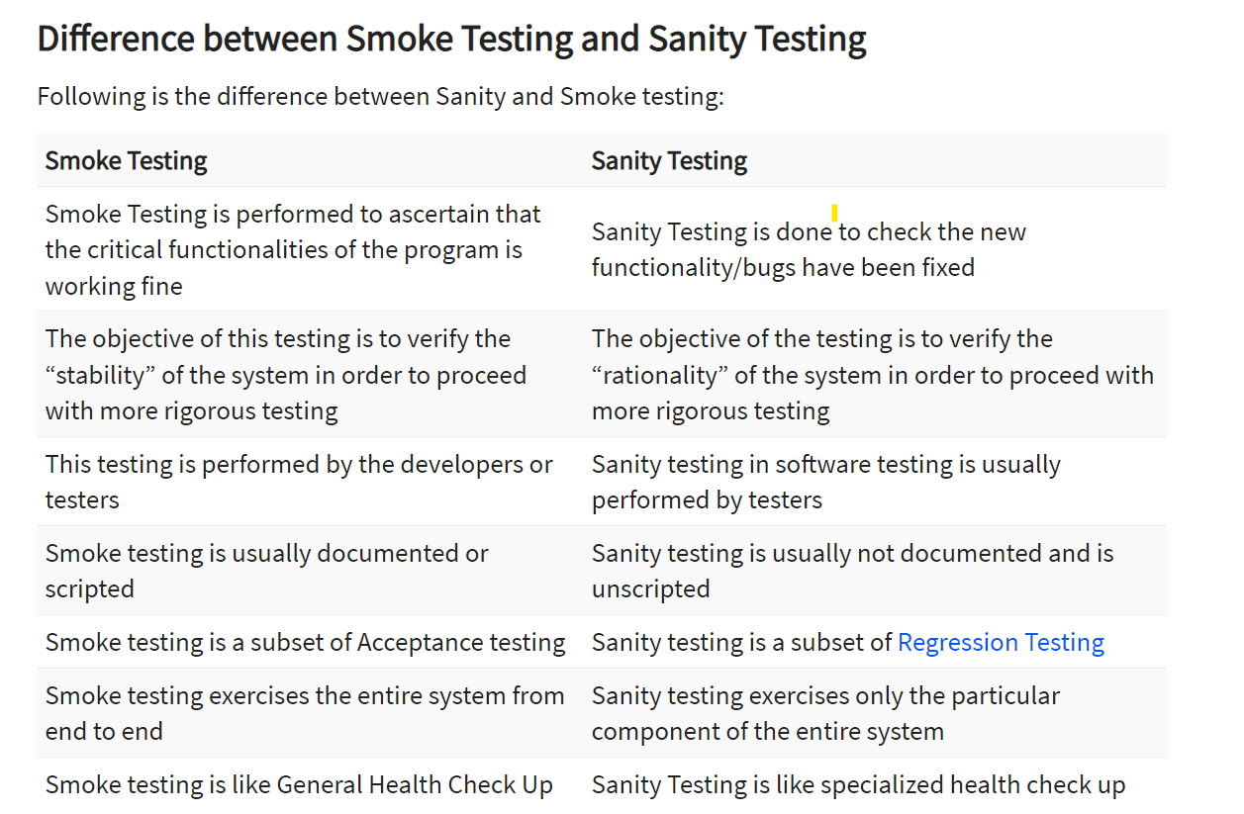

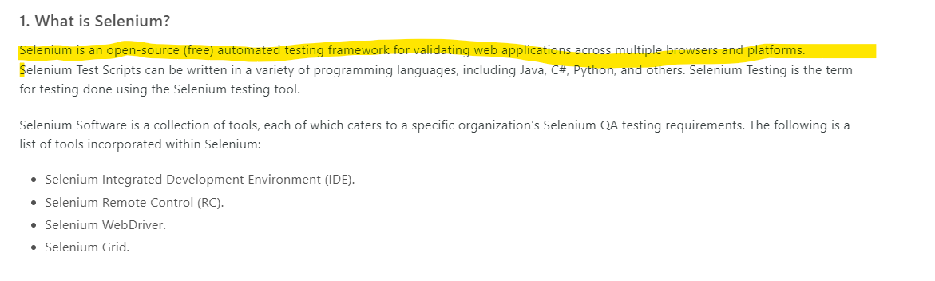

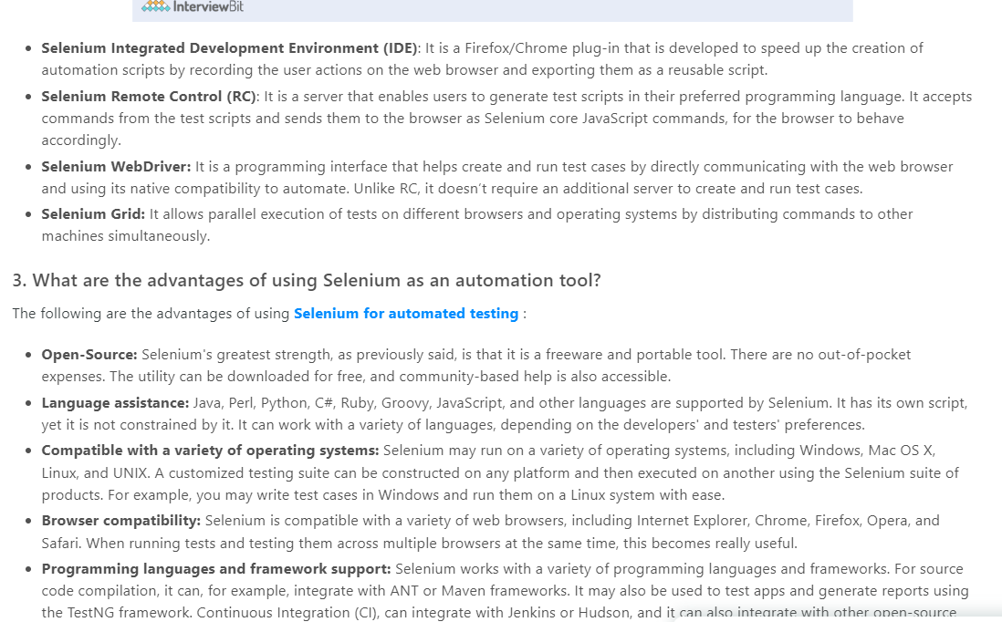

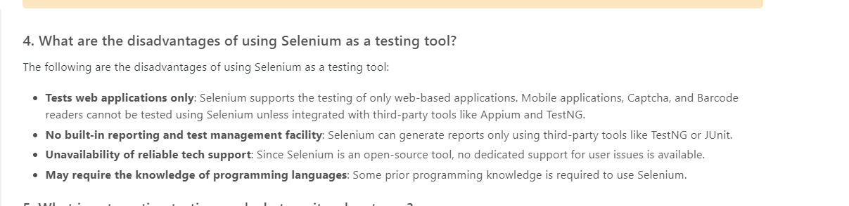

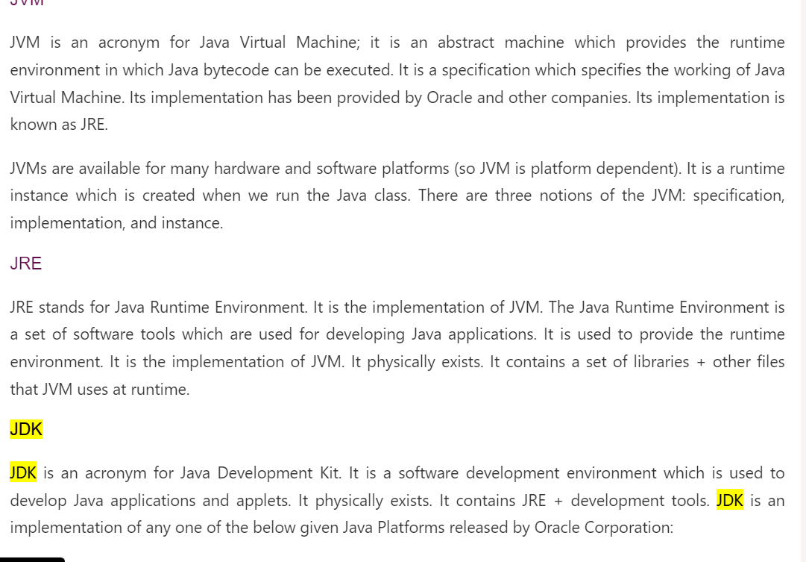

System.setProperty("webdriver.chrome.driver", "/path/to/chromedriver");

WebDriver driver = new ChromeDriver();

Key:  “webdriver.gecko.driver”

WebDriver driver = new Firefox Driver ();

Value: <Firefox binary file location>

WebDriverManager.chromedriver(). setup();

driver = new ChromeDriver();